add new event to Monitor Center as follow:
sample:
Code : UML_System_1500_FS_RW_Error
Severity: Error
Category: System
Event File System Read/Write Error
Description: <UML-ID> had IO ERROR <Description from event log>
LogFile: /var/log/message
Log: 06-14 13:39:46.393 head1 kernel: OSIC: 1204 [CRITICAL] IO Failure writing to drive 4, error code is 25.

Sentry.xml
add monitor file to Sentry.xml node
<InitialMonitoring>
<Log path="/var/log/message" syntax="${TianShanHomeDir}/etc/syntax.xml" key="TSSAndUMLEvent" type="FileLog">
<property name="SourceNetId" value="${ HostNetID}"/>
</Log>
</InitialMonitoring>

Note: (1) key="TSSAndUMLEvent"
the keyvalue can be custom, matched with syntax.xml node
(2) type="FileLog"
There are three types,
1) FileLog services log file fomat
06-18 14:46:06.630 [ DEBUG ] ProvisionState provision[cdntest1234567898809zq.com|CacheServer03.xor-media.com|/$/cache.T17/cache.L2A:Stopped(5)] committing state change: Provisioning(4) -> Stopped(5)
2) SysLog linux system log format
Jun 6 10:36:08 head1 kernel: OSIC: 1204 [CRITICAL] IO Failure writing to drive 4, error code is 25

3. WinEventLog Windows system event format
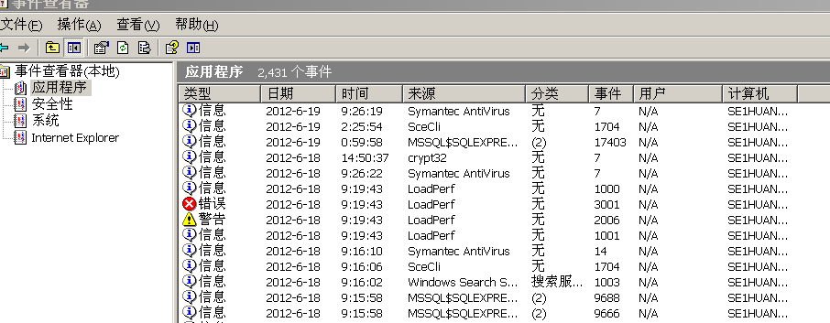

Syntax.xml
add regular expression to parse log file On TSSAndUMLEvent node.
<Syntax key="TSSAndUMLEvent">
<Rule enabled="1" regex="(.{18}).(\S+)(.*)(IO Failure)(.*)">
<Event category="System" eventName="UMLHeadIOFailure" eventId="0111" stampUTC="$FILELOGTIME2UTC($1)" sourceNetId="${SourceNetId}" >
<Param name="time" value="$ISOTIME2LOCALTIME($T)"/>
<Param name="umlid" value="$3"/>
<Param name="description" value="$6"/>
</Event>
</Rule>
</Syntax>

Note: Param name defined by user, value of regular expression matched from log file. May be used EGH_JMS.xml
- EGH_JMS.xml
Add Handler node to EGH_JMS.xml, eventName, category matched with syntax.xml
<Handler enabled="1" name="UMLHeadIOFailure" target="jboss2.SystemEvent">
<filter eventName="UMLHeadIOFailure" category="System" sourceNetId=".*">
</filter>
<message type="text">
<text content="|System|UML_System_1500_FS_RW_Error|0| |ZQ EventGateway|$time|0|$umlid had IO ERROR $description."/>
</message>
</Handler>
Note:
MonitorCenter JMS message format:
"|Component|Code| Source sequence |Host|InstanceID|Time|Properties count n|Key1=Value1|..|Description"
Component: System
Code: UML_System_1500_FS_RW_Error
Source sequence: 0
Host: matched with sentry.xml $SourceNetId
InstanceID: ZQ EventGateway
Time: matched with syntax.xml $time
Properties count n: 0
Description: $umlid had IO ERROR $description $umlid and $description matched with syntax.xml umlid description

4 DEF_SystemEvent.xml
Add follow config:
<Event category="System" code="UML_System_1500_FS_RW_Error" severity="error">
<Translation>UMLHead had IO ERROR</Translation>
<Translation locale="zh">IO错误</Translation>
</Event>
Note:
Event category matche with EGH_JMS
CODE matched with EGH_JMS.xml
Severity definded with user;
<Translation > glish display in monitor Center interface
<Translation locale="zh"> chinese display in monitor Center interface

5 COF_SystemEvent.xml
Add follow config:
<EventHandlingEntry name="UMLSystemFSRW">
<Criteria CODE="UML_System_1500_FS_RW_Error"/>
<UseDefaultAction useDefaultSNMPAction="false"/>
<UseDefaultAction useDefaultMailAction="false"/>
</EventHandlingEntry>
Note:
EventHandlingEntry name dedined by user
CODE matched with EGH_JMS.xml

